

2014-2015 Annual Report
June 5, 2015

Message from the Chapter President
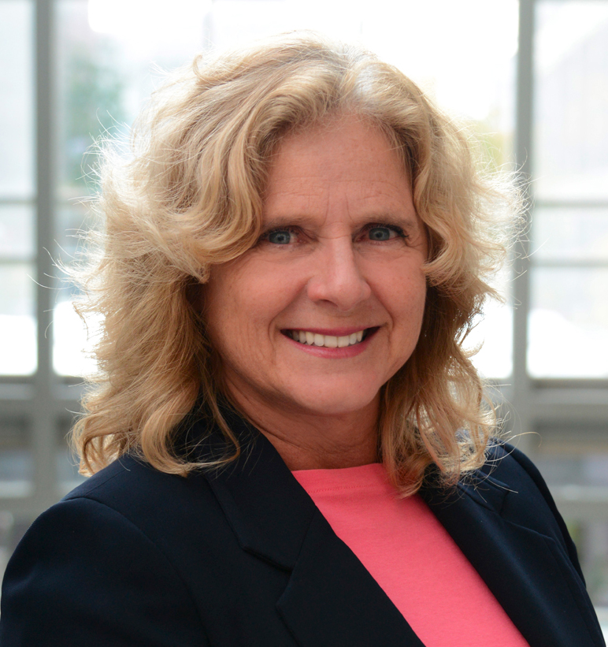
It has been a great pleasure to serve with such a talented and inspiring Executive Team this past year.
I thank each and every member of the team for your energy, enthusiasm, and commitment to the practice and promotion of Public Participation.

As we complete our second full year as a “new” Chapter, I believe we are in a strong position to continue moving forward with some of the Chapter’s strategic objectives set at an initial strategy session in June 2013, and to set new goals for our Chapter. Our membership has increased over the past year, our finances are healthy, and we have fostered some mutually-beneficial relationships with other like-minded organizations.

Several members of our executive members have taken on new professional challenges this year. Congratulations once again on your achievements and we hope you will remain involved with the Great Lakes Chapter, even if you are unable to continue in an Executive role. Prior to the second Annual General Meeting, a nomination process was conducted for new Executive Members. We’re very excited to welcome new P2 practitioners to our team! Our existing and new members are listed below.

For me, networking with our Chapter membership and connecting with members in other Chapters in the IAP2 – Canada family are always a highlight and represent great value for IAP2 members. It’s great to share ideas and experiences with other P2 practitioners, make new friends, and know you can always reach a trusted advisor or an empathetic listener just a phone call away.

Warmest regards,

Carrie-Lynn Ognibene
President, 2014-2015
Great Lakes Chapter, IAP2 Canada

The 2014-2015 Great Lakes Chapter Executive Team

Carrie-Lynn Ognibene*, President
Tracey Ehl*, Immediate Past President
Agni Papageorgiou, Vice President
Karla Kolli*, Secretary
Laurie Bruce, Treasurer
Brent Bullough*, Communications and Membership Coordinator
Inayat Singh*, Research and Special Event Coordinator
Mike Sullivan, Chapter Liaison
[* denotes returning to Executive Team in 2015-2016]
Welcome to the 2015-2016 Great Lakes Chapter Executive Team

Karla Kolli, President
Carrie-Lynn Ognibene, Immediate Past President
Donna Kell, Vice President
Kyal Butler, Secretary
Tracey Ehl, Treasurer
Brent Bullough, Member-at-Large
Michelle Dwyer, Member-at-Large
Tracy Manolakakis, Member-at-Large

Executive roles were determined at the June 4, 2015 Annual General Meeting and will be communicated via the Chapter newsletter.

Membership

Here we grow again! Great Lakes Chapter membership increased from 58 in March 2014 to 69 at writing of this report. Our members represent a diverse cross-section of practitioners from the public and private sectors.

Strategic Direction 2014-2015

Building on the Great Lakes Strategy Session of June 2013, the Chapter’s focus over the past year was to progress in “baby steps” with priority on:

- Improving communication with members and on the Chapter website
- Growing Chapter membership
- Offering learning and networking/social opportunities
- Broadening communication with non-members (i.e. practitioners outside of IAP2)
- Developing strategic partnerships (e.g. OPPI, OAIA, etc.)
- Participating in advocacy, research and policy development where possible.

Highlights and Accomplishments

The Chapter gained some very good exposure at the following events:
- participation of Great Lakes members (Inayat Singh, Sherif Kinaway and IAP2 Canada’s Research Initiative
- a presentation (Ignite Session!) by members of the Executive Team (Tracey Ehl, Karla Kolli and Mike Sullivan) at the Ontario Professional Planners Institute (OPPI) Symposium held in Niagara Falls in October 2014

- continuation of our partnership with the Strategy Institute, and the opportunity to have an IAP2 Great Lakes Chapter booth and attendees at the Institute’s 4th annual Public Consultation Summit held in Toronto in November 2014. Executive Team members Mike Sullivan and Carrie-Lynn Ognibene joined IAP2 Canada’s Brenda Pichette in moderating sessions at the conference.
- continuation of our association with IAP2 Trainer Delaney and Associates, taking the opportunity to introduce the course attendees to IAP2, its objectives and member benefits, and to couple networking events with training sessions when they are scheduled in the Toronto area
- a well-attended “Winter Schmooze” (hopefully the first annual) on February 3, 2015 at the Blake House in Toronto featuring a panel on Dialogue and Deliberation Tips: Learning from successes and horrors! and guest speakers Richard Delaney (Delaney & Associates) and Jason Diceman, City of Toronto, Stakeholder Engagement Manager. More than 30 members and guests attended.
- And finally, special guest Richard Pietro will bring his open government tour to the Great Lakes AGM on June 4, 2015.

Financial Position

Thanks to an IAP2 Chapter grant secured by our Acting Treasurer, the Chapter’s financial position is strong heading into our 3rd year. Please see the attached Treasurer’s report.

Looking Forward

There are many things the new Chapter Executive will want to evaluate and plan for the coming year, including continuing to build new partnerships, and participating in many initiatives at the IAP2 – Canada level such as a review of the P2 Spectrum, a new funding formula for Chapters, and the potential to assist with the planning of the 2016 IAP2 North American Conference in either Ottawa or Montreal.

Opportunities abound for our Chapter members to become involved in exciting initiatives and to develop their leadership, organizational and communication skills. If you are interested in these opportunities, please let members of the Executive know. We are stronger as a team.

Contact Us

For more information about the Great Lakes Chapter, please contact us at:
greatlakeschapter@iap2canada.ca

Draft Annual Report prepared by:
Carrie-Lynn Ognibene, Chapter President, 2014-2015

Final Annual Report adopted: June 4, 2015 at the Chapter’s Annual General Meeting.
Attachment

Financial Report as of December 31, 2014
IAP2 Canada – Great Lakes Chapter
Prepared by Laurie Bruce, Treasurer

Date | Memo/Description | Revenue | Expenses | Balance
01/01/2013 | Opening balance | 1,207.07 |  | 1,207.07
09/15/2013 | Refreshments for Strategic Planning Session |  | -16.95 | 1,190.12
09/15/2013 | Room rental for Strategic Planning Session (Vaughan Public Library) |  | -33.90 | 1,156.22
09/15/2013 | Strategic Planning Session – Facilitator Honorarium |  | -350.00 | 806.22
02/04/2014 | Networking Session Refreshments |  | -136.14 | 670.08
11/20/2014 | April 2014 expenses |  | -15.81
 | Current Balance as of December 31, 2014 |  | 552.80 | 654.27

