

2015-2016 Annual Report
June 20, 2016

DRAFT FOR DISCUSSION AT JUNE 21, 2016 AGM

Message from the Chapter President
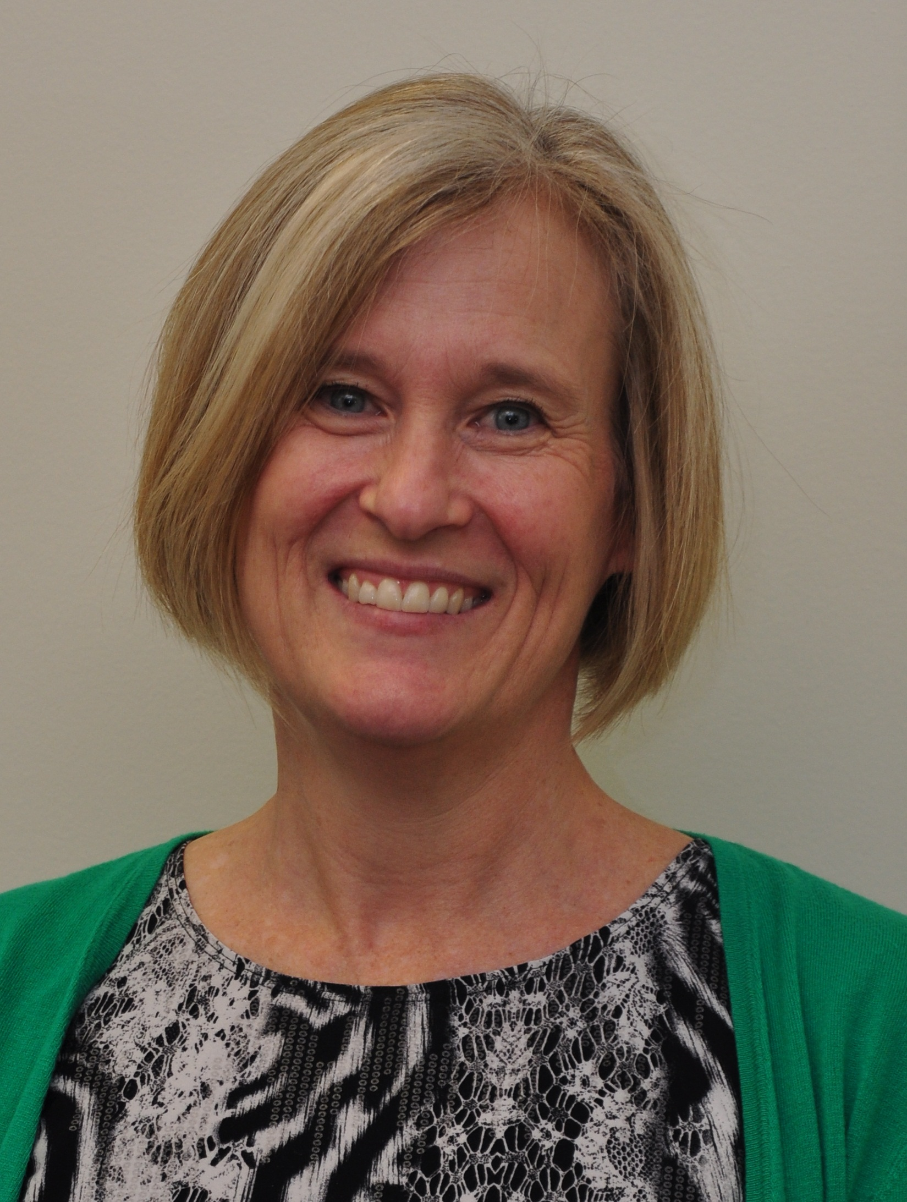
A year goes by so fast…. It seems like yesterday that we were sorting our roles on the 2015-2016 Executive Committee! We have a great mix of practitioners who bring perspectives and experiences from the public sector, the private sector and associations. It has been a pleasure to get to know everyone on the Executive Team and be able to work with you over the past year. Thank you all for your passion for public participation!!

As a Chapter we are continuing to move forward, growing in membership and outreach activities. In January we met to chart out the calendar year with the aim of understanding more about what members want and offering more activities. Through the rest of this year we have some great ideas to implement together. We have a solid base of members and “friends” to tap into and will soon be polling them to better understand what we can do to bring value to our members. Looking into the future, we also hope to increase our networking strength so that we can reach more of the Great Lakes. The other IAP2 Canada Chapters are a great resource that we can continue to tap into for ideas and take advantage of learning from each other.

This year we will have a full 9 members on the Executive Team – many hands make light work! While a couple of members are moving on to other challenges we are joined by some new faces. Being on the IAP2 Canada Great Lakes Chapter Executive Team provides a great opportunity to network, exchange best P2 practices and be a part of an ever important effort to improve stakeholder engagement and communication. Effectively communicating complex information, bringing people together to discuss “issues that matter”, and helping people listen to each other will continue to be critical elements in our increasingly technological world.

I congratulate all of us on our achievements this year and for the exciting year that I know is ahead of us. I appreciate the opportunity to serve as the President this past year and look forward to continuing with the new Executive Team in 2016-2017.

Cheers,
Karla Kolli
President, 2015-2016, Great Lakes Chapter, IAP2 Canada

The 2014-2015 Great Lakes Chapter Executive Team [* denotes returning to Executive Team in 2016-2017]

Karla Kolli*, President
Carrie-Lynn Ognibene*, Past President
We would like to extend a huge THANK-YOU to everyone for their work on the Executive Team. A special Thanks to our outgoing team members - Brent and Inayat.
Donna Kell*, Vice President
Tracey Ehl*, Treasurer
Kyal Butler*, Secretary
Brent Bullough, Communication
Tracy Manolakakis*, Member-at-Large
Inayat Singh, Member-at-Large

Welcome to the 2016-2017 Great Lakes Chapter Executive Team

Karla Kolli, Past President
Donna Kell,
Kyal Butler
Tracy Manolakakis
Tracey Ehl
Carrie-Lynn Ognibene
Chris Gurski,
David Nagler
Jodi Ball

Executive roles will be determined at the June 21, 2016 Annual General Meeting.

Membership

As of January 2015, there were 77 active Great Lakes Chapter memberships, 54 lapsed members and 42 “friends”. Our members represent a diverse cross-section of practitioners from the public and private sectors. An important action for the coming year will be to update our membership and encourage lapsed members to rejoin and friends to join.

Strategic Direction 2015-2016

The Executive Team met on January 20, 2016 to design a program of activities for the calendar year. We confirmed that our vision for the Great Lakes Chapter was to provide members with:
- Opportunities for education, professional development and networking.
- A culture of interaction, connection and sharing among P2 practitioners (members and non-members).
- Support to achieve best practice in P2 and to celebrate projects and people that embrace this commitment.

The IAP2 Great Lakes Chapter identified the following actions to achieve this vision:
- Organize training and learning opportunities
- Host social events
- Communicate with members and non-members using multiple approaches including e-newsletters and web
- Develop strategic partnerships that will provide value for members
- Recognize and celebrate people and projects
- Advocate, research, develop policy and provide commentary on P2

Highlights and Accomplishments in 2015-2016

The Chapter gained some very good exposure at the following events:
- The June AGM included an excellent presentation by Richard Pietro on his Open Government Tour at the 2015 AGM.
- A IAP2 Great Lakes Chapter booth was staffed at the Strategy Institute’s annual Public Consultation Summit held in Toronto on December 1st and 2nd, 2015. Chris Gurski attended the session and looked after the booth. At the booth we had our 1 page outline of the Great Lakes Chapter.
- Continuing our association with IAP2 Trainer Delaney and Associates, Executive Team members attended training sessions in November to promote IAP2 and the Great Lakes Chapter.
- Prepared a survey of members to determine what they would like to see from the Chapter. The survey will be distributed following the AGM.

Financial Position

Thanks to an IAP2 Chapter grant secured by our Acting Treasurer, the Chapter’s financial position is strong heading into our 4th year. Please see the attached Treasurer’s report.

Looking Forward

There are many things the new Chapter Executive will want to evaluate and plan for the coming year, including continuing to build new partnerships, and participating in many initiatives at the IAP2 – Canada level and participating in the 2016 IAP2 North American Conference in Montreal.

Some of the initiatives for discussion include those raised during the Executive Teams planning meeting in January 2016 including:
- More frequent e-blasts/newsletters/web postings to share information (e.g. profile people/projects, training ideas, events)
- Issuing of the survey that has been developed to poll members
- Networking opportunities connected to IAP2 training
- Attendance at the Strategy Institute Public Consultation Conference
- Fall event
- Membership growth

Contact Us

For more information about the Great Lakes Chapter, please contact us at:
greatlakeschapter@iap2canada.ca

Draft Annual Report prepared by:
Karla Kolli, Chapter President, 2015-2016

Final Annual Report adopted: June 21, 2016 at the Chapter’s Annual General Meeting (to be confirmed at AGM).
Attachment

Financial Report as of June 16, 2016
IAP2 Canada – Great Lakes Chapter
Prepared by Tracey Ehl, Treasurer

IAP2 Canada - Great Lakes - Financial Information - June 2015 to June 2016

Date | Description | Amount | Tax | Total Transaction | Balance
1-Jun-15 | Opening Balance |  |  |  | 1823.14
4-Jun-15 | food for 2015 AGM | 49.56 | 4.19 | 53.75 | 1769.39
4-Jun-15 | Reverse tax |  | 4.19 | 4.19 | 1773.58
11-May-16 | Chapter Funding Grant | 2500 |  | 2500 | 4273.58
 |  |  |  |  | 4273.58
Note: GST is included in the IAP2 Canada account, therefore it is neutral in the Great Lakes Chapter Transaction Record.
Submitted by: Tracey Ehl, Treasurer

